***ReadMe File: This file shows the input and the output that is obtained for each question.***

**Question1: Recursively searching for FastaFiles**

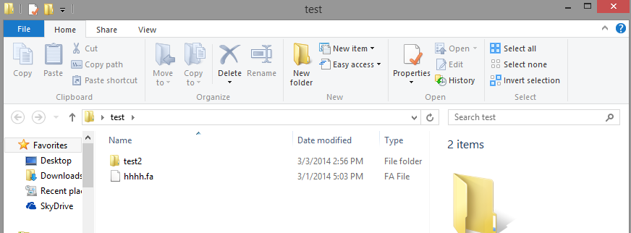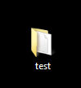

**This is Level 0 when we first click on the folder so when running the program we should only get hhhh.fa**

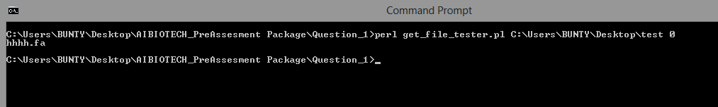

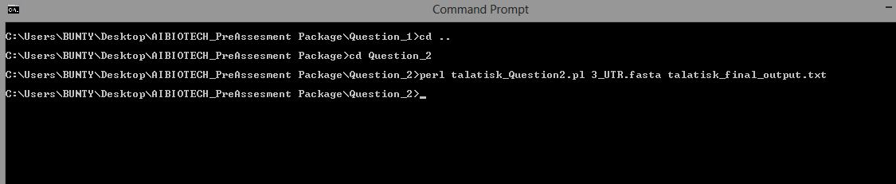**Question2: Binning**

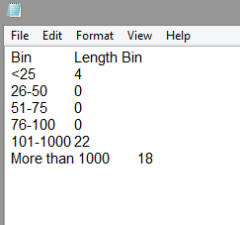

**OUTPUT OF THE ABOVE RUN:**

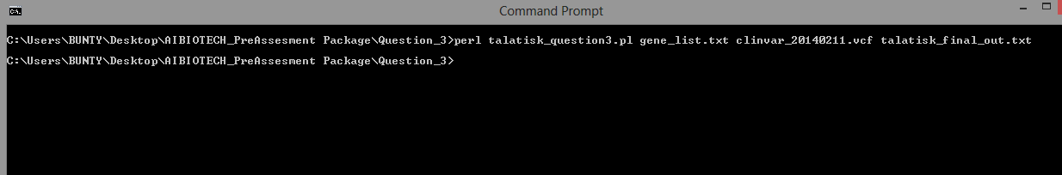**Question3: Merging 2 files** 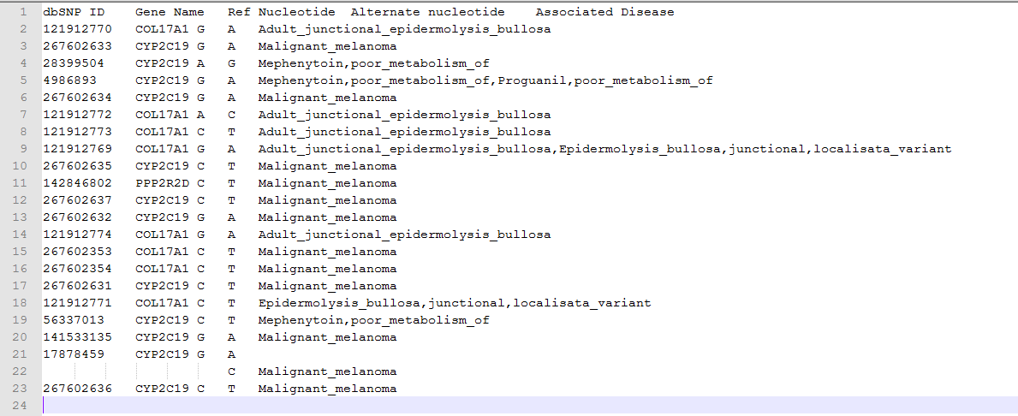

**OUTPUT OF THE ABOVE RUN:**

I have completed all tasks to the best of my ability, please let me know if there are any other questions.

Thank you.